Erasmus Eco Rules

- 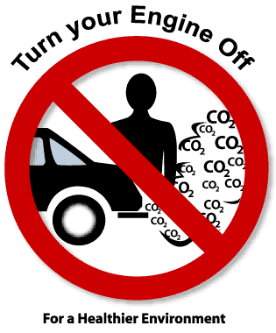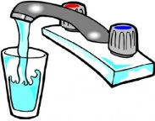Children remind their parents to switch off the engines in the car if you’re stopped for more than 2 minutes.
- Don’t waste water – fill a cup rather than the tap. It’s better to have a shorter shower than a long bath!
- Turn off the lights when you leave the room.
- Don’t use plastic bags for your lunch or use reusable containers to carry your food to school.
- Recycle your rubbish
- Use a bus, cycle or walk if you can.
- Go Vegetarian one day a week.
- Don’t leave the computer on standby
- Look after the environment by keeping it litter free.
- 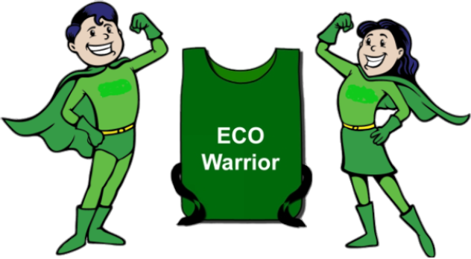Don’t waste heat, close doors.

